 | SIMATS ENGINEERING  Department of Computer Science and Engineering  CSA15 Cloud Computing and Big Data Analytics  CO2 AT3 - Capstone Cloud Infrastructure Case Analysis and Defense  Editable student template for application-based cloud virtualization and SDDC/cloud operations defense
Assessment Metadata
Course Code | CSA15
Course Title | Cloud Computing and Big Data Analytics
Assessment | CO2 AT3 - Capstone Cloud Infrastructure Case Analysis and Defense
Submission Type | Individual digital case analysis and infrastructure defense based on the same capstone title used in CO1, CO2 AT1 and CO2 AT2
Faculty | Dr C. Rajesh Babu
Employee ID | SSETSCS415
Submission Mode | Completed DOCX template and GitHub repository link through Google Classroom
How This Template Works
- Use the same capstone title used in CO1, CO2 AT1 and CO2 AT2.
- Do not recalculate all VM sizing or repeat all configuration screenshots. Summarize the final AT1/AT2 evidence and use it for design defense.
- Answer all five questions with application-oriented reasoning connected to the capstone product.
- Include sustainable cloud operation decisions wherever relevant: right-sized resources, log retention, storage lifecycle, scheduled shutdown, API-call reduction and VM/container/serverless comparison.
- Paste the final topology diagram in the given response area. The sample diagram is only a structure; redraw it for the student's own product.
- Upload this completed document and supporting evidence to GitHub, then submit the repository link through Google Classroom.
Assessment Focus
AT1 answered what VM is required. AT2 showed configuration or simulation evidence. AT3 asks whether the student can defend the complete infrastructure design under application, security, operations and failure conditions.
Student and Capstone Details
Student Name | M Deepika
Register Number | 192311027
Class / Slot | Slot B
Capstone Title | Cloud-Based Medicine Inventory Management System
CO1 Evidence Link | https://github.com/mdeepika2006/cloudcomputing/blob/main/192311027%20CO2%20AT1%20CLOUD%20COMPUTING.docx
CO2 AT1 VM Recommendation | vCPU: ____2 RAM: __4__ GB Storage: __30__ GB VM Class: b2asv2____
CO2 AT2 Evidence Link | https://github.com/mdeepika2006/cloudcomputing/blob/main/192311027%20CO2%20AT2.docx
GitHub Repository Link | https://github.com/mdeepika2006/cloudcomputing
Submission Date | 03-08-2026
Evidence Carry-Forward Summary
Evidence Source | Student Entry | How It Supports AT3 Defense
CO1 concept map / presentation | Cloud-Based Medicine Inventory Management System architecture | Explains the overall design and modules of the project
CO2 AT1 sizing workbook | 2 vCPU, 4 GB RAM, 30 GB storage | Justifies the VM resources required for deployment
VM calibration sheet | Standard B2as v2 | Shows proper VM selection for the workload
CO2 AT2 practical evidence | Azure VM creation and Nginx deployment screenshots | Demonstrates practical cloud deployment
Capstone architecture decision | Web application + cloud database | Explains the deployment architecture
Q1: Virtualization Value and Capstone Cloud Deployment Summary
Explain your capstone product, expected workload, cloud need and deployment context. Analyze how virtualization improves cost efficiency, resource utilization, workload isolation, infrastructure flexibility and cloud deployment readiness for your product.
Design Point | Student Response
Capstone product and users | Cloud-Based Medicine Inventory Management System for pharmacists and customers
Expected workload | Medium workload with multiple users accessing medicine data
Cloud need | Cloud storage and remote access are required
Virtualization value | Efficient resource sharing and scalability
Cost and utilization benefit | Reduces hardware cost and improves utilization
Isolation and flexibility benefit | Provides secure and isolated environments
Case Analysis Response: Write 8-12 technical lines connecting virtualization value to your capstone product.

The Cloud-Based Medicine Inventory Management System is designed to help pharmacists and customers manage medicine details efficiently. The application is expected to handle a medium workload with multiple users accessing the system simultaneously. Cloud deployment is necessary because the system requires remote access, secure data storage and continuous availability. Virtualization allows multiple virtual machines to run on a single physical server, which reduces hardware costs and improves resource utilization. It also provides workload isolation, ensuring that failures in one virtual machine do not affect others. Virtualization offers flexibility by allowing CPU, memory and storage resources to be increased or decreased based on demand. It simplifies deployment, maintenance and scaling of the application. Therefore, virtualization improves cost efficiency, security, flexibility and cloud readiness for the capstone product.

Q2: Rapid Provisioning, Testing and Virtual Machine Lifecycle Case
Using your CO2 AT1 VM recommendation and CO2 AT2 practical evidence, explain how virtual machines, VM images, templates, snapshots, clones or containers support rapid provisioning, testing, deployment, rollback and maintenance for your capstone product.
Lifecycle Element | AT1/AT2 Evidence Used | Capstone Use / Justification
VM image or base environment | Ubuntu 24.04 LTS | Base operating system for deployment
Template or repeatable setup | VM template | Fast creation of new VMs
Snapshot / rollback | Azure snapshot | Restore the previous state if errors occur
Clone / testing copy | VM clone | Test new features safely
Container or VM decision | Virtual machine | Suitable for the application
Maintenance and update plan | Azure updates | Easy maintenance and updates
Case Analysis Response: Explain how lifecycle practices reduce deployment delay and risk.
Virtual machines and lifecycle management practices help in the rapid deployment and maintenance of the Cloud-Based Medicine Inventory Management System. A base VM image with Ubuntu provides a ready-to-use environment for application deployment. Templates make it easy to create multiple virtual machines with the same configuration, reducing setup time. Snapshots allow the system to be restored to a previous state if errors occur during updates or testing. Clones create separate testing environments without affecting the original application. Virtual machines provide better isolation and control for the capstone project, while regular maintenance and updates improve security and reliability. These lifecycle practices reduce deployment delays, minimize risks and ensure smooth operation of the application in the cloud environment.

Q3: Final Cloud Deployment Topology and SOA/API Service Integration Case
Draw and explain the final deployment topology for your capstone product. Show frontend, backend/API, database, storage, authentication, notification, analytics and any VM/container/managed cloud service components. Explain how SOA/API-based integration connects these modules and supports modular cloud service design.
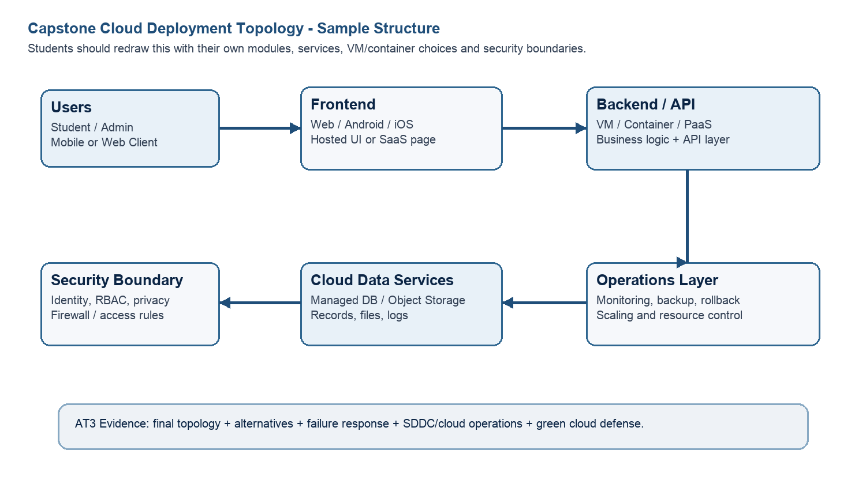
Architecture Component | Technology / Service | VM / Container / Managed Service / SaaS | Integration Method
Frontend | HTML, CSS and JavaScript web application | Container | HTTPS REST API
Backend/API | Java Spring Boot API | Azure VM / Container | REST API using JSON
Database | MySQL Database | Managed Service | JDBC secure database connection
Storage | Azure Blob Storage | Managed Service | Azure Storage API
Authentication | Azure Entra ID / JWT authentication | Managed Service | OAuth 2.0 and JWT tokens
Notification | Email and SMS notification service | SaaS / Managed Service | Notification API
Paste or draw the final capstone deployment topology diagram here.

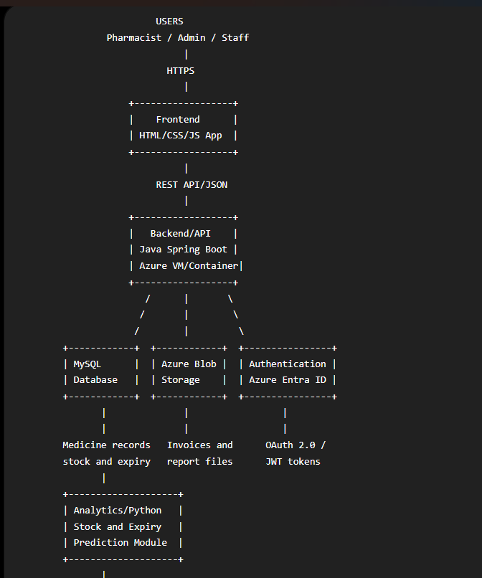

SOA/API Integration Explanation: Explain how services communicate and why modular service design is useful.
The Cloud-Based Medicine Inventory Management System follows a modular Service-Oriented Architecture in which each module performs a separate function. The frontend communicates with the backend through secure REST APIs using HTTPS and JSON. The backend API processes user requests and connects to the MySQL database for medicine, stock, supplier and expiry information. Azure Blob Storage stores invoices, reports and backup files. The authentication service verifies users through OAuth 2.0 and JWT tokens before allowing access to protected resources. The Python analytics module receives medicine data through an API and generates stock availability and expiry predictions. The notification service uses APIs to send email or SMS alerts when stock becomes low or medicines approach their expiry dates. This modular design makes individual services easier to develop, test, maintain, update and scale without affecting the complete system.

Q4: Design Alternatives, Identity, Access and Federated Cloud Privacy Case
Compare at least two deployment alternatives for your capstone product, such as single VM, multi-tier VM, containerized deployment, managed backend, federated cloud or hybrid cloud model. Justify the selected design by analyzing identity management, role-based access control, federated access, data sharing, privacy protection and security risks.
Deployment Alternative | Advantages | Limitations / Risks | Identity and Privacy Impact
Alternative 1 | Simple deployment, easy management and lower initial cost | Single point of failure, limited scalability and all modules share the same resources | Authentication is simple, but a VM compromise may expose the entire application and database
Alternative 2 | Better security, scalability, isolation and independent resource management | More configuration, monitoring and management are required | Frontend, backend and database can have separate access controls, improving privacy
Selected design | Provides scalable frontend/backend services, managed database, secure storage and better availability | Slightly higher cost and requires careful configuration | Supports centralized identity, RBAC, encrypted data and controlled access between modules
Security Area |  | Student Decision
User roles |  | Administrator, Pharmacist, Inventory Staff and Viewer
Authentication method |  | Azure Entra ID with username/password, OAuth 2.0 and JWT tokens
Role-based access control |  | Each role is granted only the permissions required for its work
Federated access / partner access |  | Authorized suppliers or partner pharmacies may access limited APIs using federated identity
Sensitive data handled |  | User details, medicine stock records, supplier information, invoices and transaction reports
Privacy protection decision |  | Encryption, HTTPS, least-privilege access, database backups, audit logs and restricted public access
Case Analysis Response: Defend why the selected design is better for identity, access and privacy.
The multi-tier Azure deployment with managed services is selected because it provides better security, scalability and privacy than a single-VM deployment. In a single VM, the frontend, backend and database share the same environment, so a failure or attack may affect the entire application. In the selected design, the frontend, backend API, database and storage are separated into different service layers. Azure Entra ID provides centralized authentication, while role-based access control ensures that administrators, pharmacists, inventory staff and viewers receive only the permissions required for their roles. Federated access can be provided to trusted suppliers through limited and authenticated APIs without exposing the complete system. Sensitive medicine records, supplier details and invoices are protected using HTTPS, encryption, access restrictions and audit logs. Managed database and storage services also provide backup, monitoring and recovery support. Therefore, the selected multi-tier design provides stronger identity management, controlled access, workload isolation and privacy protection.
Q5: Software-Defined Datacenter and Cloud Operations Defense Case
Analyze how your infrastructure will respond to operational and failure scenarios such as VM failure, database growth, traffic spike, credential leakage, service outage, resource contention or cost increase. Explain how SDDC concepts and cloud operations practices such as automated provisioning, software-defined networking, software-defined storage, monitoring, logging, backup, rollback, scaling, resource control and maintenance improve the final infrastructure design. Include Green Computing decisions such as resource right-sizing, storage lifecycle control, log retention, API-call reduction, scheduled shutdown, VM/container/serverless comparison and carbon/energy proxy indicators where relevant.
Operational / Failure Scenario | Expected Impact | SDDC / Cloud Operations Response | Evidence or Control
VM failure | Application becomes unavailable | Automatic VM restart and backup recovery | Azure Backup
Database growth | Reduced performance | Increase storage and optimize database | Managed database scaling
Traffic spike | Slow response time | Auto-scaling and load balancing | Azure Monitor
Credential leakage | Unauthorized access | Reset credentials and enable MFA | Authentication logs
Service outage | Service interruption | Failover and disaster recovery | Backup snapshots
Resource contention | CPU and memory shortage | Dynamic resource allocation | Monitoring dashboard
Cost increase | Higher cloud expenses | Right-size resources and shut down idle VMs | Cost reports
Operational Readiness Area |  | Student Plan
Automated provisioning |  | Use VM templates and automation scripts
Software-defined networking |  | Configure virtual networks and firewalls
Software-defined storage |  | Use Azure Blob Storage
Monitoring and logging |  | Use Azure Monitor and activity logs
Backup and rollback |  | Use snapshots and backups
Scaling and elasticity |  | Increase CPU, RAM and storage when needed
Resource control and maintenance |  | Regular updates and performance checks
Green Computing and sustainability control |  | Shut down unused resources
Green Cloud Decision |  | Student Justification
VM right-sizing from CO2 AT1 |  | 2 vCPU, 4 GB RAM and 30 GB storage are sufficient
VM vs container vs serverless choice |  | VM is selected because it provides complete control
Scheduled shutdown / idle-resource control |  | Stop VMs when they are not in use
Log and file retention policy |  | Delete old logs after 30 days
Storage lifecycle and backup cleanup |  | Remove outdated backups periodically
API-call or polling reduction |  | Reduce unnecessary API requests
Carbon/energy proxy indicator to track |  | CPU utilization and power consumption
Final Infrastructure Defense Statement: State whether the design is ready for prototype, pilot or production. Defend reliability, security, SDDC/cloud operations and Green Computing improvements required next.
The proposed infrastructure is ready for the prototype and pilot stages of deployment. The design provides reliability through backup, snapshots and automatic recovery mechanisms. Security is improved using authentication, role-based access control and encrypted communication. Software-defined datacenter concepts such as virtual networking, software-defined storage and automated provisioning improve flexibility and simplify management. Cloud operations practices such as monitoring, logging, scaling and rollback reduce downtime and operational risks. Green Computing strategies, including VM right-sizing, scheduled shutdown and storage cleanup, help reduce energy consumption and cloud costs. Before production deployment, advanced monitoring, load balancing and stronger security policies should be implemented.
CO2 Reflection and Individual Defense
This section must be individually written. It should show what the student understands from the complete CO2 chain: infrastructure sizing, practical configuration evidence and final operations defense.
Reflection Prompt | Student Response
What is the strongest infrastructure decision in your capstone design? | The strongest decision is selecting a multi-tier cloud architecture with virtualization support.
Which CO2 concept became clearer after AT1, AT2 and AT3? | Infrastructure sizing, virtualization and cloud deployment concepts became clearer.
Which risk is most serious for your capstone: failure, cost, privacy, scaling or sustainability? | Privacy and security are the most serious risks because sensitive medicine data must be protected.
What evidence would you show during viva to defend your infrastructure design? | VM sizing workbook, Azure VM screenshots, Nginx deployment and architecture diagrams.
What will you improve before final capstone deployment? | I will improve monitoring, security, backup and scalability features before deployment.

Student-Facing Assessment Criteria
Criteria | Descriptor
Capstone continuity | The answer uses the same capstone title and connects CO1, CO2 AT1 and CO2 AT2 evidence.
Virtualization and lifecycle reasoning | VM, image, snapshot, clone, container or managed-service decisions are technically justified.
Topology and integration clarity | Architecture diagram and SOA/API explanation show clear module interaction.
Identity, access and privacy | Roles, authentication, RBAC, federated access, sensitive data and privacy decisions are defended.
SDDC/cloud operations | Failure response, monitoring, logging, scaling, backup, rollback and resource control are addressed.
Green Computing defense | Right-sizing, retention, API efficiency, idle-resource control and sustainable cloud choices are explained.
Submission quality | GitHub, template completion, evidence references and individual reflection are complete.
GitHub and Google Classroom Submission
Repository Item | Expected Content
README.md | Capstone title, student details, final VM recommendation, deployment topology summary and AT3 evidence index.
Completed AT3 document | This completed editable DOCX or exported PDF if instructed.
Diagram image | Final topology diagram if created separately.
Evidence references | Links or screenshots from CO1, CO2 AT1 and CO2 AT2 as needed.
Green Computing note | Short README section explaining sustainable cloud choices and resource-control decisions.
Google Classroom | Submit the GitHub repository link through GCR.
Student Assurance
I confirm that this case analysis, design reasoning, topology diagram and final defense statement were prepared individually by me for the stated capstone title. I have not uploaded passwords, tokens, private keys or sensitive account information.
Student Name | M Deepika
Register Number | 192311027
Signature | M.Deepika
Date | 03-08-2026
Faculty Verification
Faculty Name | Dr C. Rajesh Babu
Employee ID | SSETSCS415
Constructive Feedback / Remarks
Strength Observed
Improvement Suggested
Signature / Date

